16th SUNDAY IN ORDINARY TIME - A

1st Reading: Wisdom 12:13, 16-19
For who will say, “What have you done?” or who will resist your judgment?
Who will accuse you for the destruction of nations that you made?
Or who will come before you to plead as an advocate for the unrighteous?
For neither is there any god besides you, whose care is for all people, to whom you should prove that you have not judged unjustly; nor can any king or monarch confront you about those whom you have punished.
You are righteous and you rule all things righteously, deeming it alien to your power to condemn anyone who does not deserve to be punished.
For your strength is the source of righteousness, and your sovereignty over all causes you to spare all.
For you show your strength when people doubt the completeness of your power, and you rebuke any insolence among those who know it.
Although you are sovereign in strength, you judge with mildness, and with great forbearance you govern us; for you have power to act whenever you choose.
Through such works you have taught your people that the righteous must be kind, and you have filled your children with good hope, because you give repentance for sins.

Responsorial: Psalm 85:5-6, 9-10, 15-16
Resp: Lord, you are good and forgiving
O Lord, you are good and forgiving,
full of love to all who call.
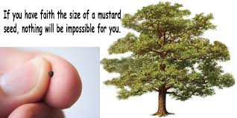
Give heed, O Lord, to my prayer
and attend to the sound of my voice. Resp:

All the nations shall come to adore you
and glorify your name, O Lord:
for you are great and do marvellous deeds,
you who alone are God. Resp:

But you, God of mercy and compassion,
slow to anger, O Lord,
abounding in love and truth,
turn and take pity on me. Resp:

2nd Reading: Romans 8:26-27
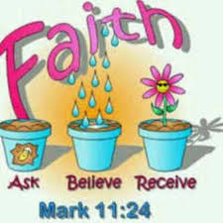
Likewise the Spirit helps us in our weakness; for we do not know how to pray as we ought, but that very Spirit intercedes with sighs too deep for words. And God, who searches the heart, knows what is the mind of the Spirit, because the Spirit intercedes for the saints according to the will of God.

Alleluia, Alleluia !
Blessed are you, Father, Lord of heaven and earth;
You have revealed to little ones the mysteries of the kingdom.
Alleluia !

Gospel: Matthew 13:24-43
The Parable of the Mustard Seed
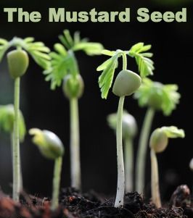

Jesus put before them another parable: “The kingdom of heaven may be compared to someone who sowed good seed in his field; but while everybody was asleep, an enemy came and sowed weeds among the wheat, and then went away. So when the plants came up and bore grain, then the weeds appeared as well. And the slaves of the householder came and said to him, ‘Master, did you not sow good seed in your field? Where, then, did these weeds come from?’ He answered, ‘An enemy has done this.’ The slaves said to him, ‘Then do you want us to go and gather them?’ But he replied, ‘No; for in gathering the weeds you would uproot the wheat along with them. Let both of them grow together until the harvest; and at harvest time I will tell the reapers, Collect the weeds first and bind them in bundles to be burned, but gather the wheat into my barn.'”
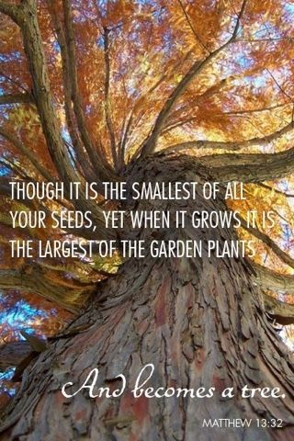
He put before them another parable: “The kingdom of heaven is like a mustard seed that someone took and sowed in his field; it is the smallest of all the seeds, but when it has grown it is the greatest of shrubs and becomes a tree, so that the birds of the air come and make nests in its branches.” He told them another parable: “The kingdom of heaven is like yeast that a woman took and mixed in with three measures of flour until all of it was leavened.” Jesus told the crowds all these things in parables; without a parable he told them nothing. This was to fulfill what had been spoken through the prophet: “I will open my mouth to speak in parables; I will proclaim what has been hidden from the foundation of the world.” Then he left the crowds and went into the house. And his disciples approached him, saying, “Explain to us the parable of the weeds of the field.” He answered, “The one who sows the good seed is the Son of Man; the field is the world, and the good seed are the children of the kingdom; the weeds ar the children of the evil one, and the enemy who sowed them is the devil; the harvest is the end of the age, and the reapers are angels. Just as the weeds are collected and burned up with fire, so will it be at the end of the age. The Son of Man will send his angels, and they will collect out of his kingdom all causes of sin and all evildoers, and they will throw them into the furnace of fire, where there will be weeping and gnashing of teeth. Then the righteous will shine like the sun in the kingdom of their Father. Let anyone with ears listen!

REFLECTIONS:
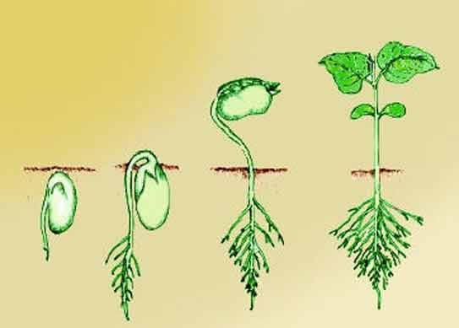
There were people in Our Lord’s time who wanted him to separate the bad from the good as well. Among them were people who claimed the moral high ground, the Pharisees whose name means “the separated ones.” Even John the Baptist expected Jesus to separate the cream from the skim, to have only holy people around him. John foretold that Our Lord would separate the chaff from the wheat. He said (Mt 3:12) “He will gather his wheat into his barn; but the chaff he will burn in a fire that will never go out.” That’s precisely what Our Lord didn’t do. He had all sorts of people around him, a rainbow coalition of people, the learned, the ignorant, the good-living, the bad-living, tax-collectors, prostitutes, the lot. What in God’s name is he doing, they said. Why doesn’t he get down to business? Why doesn’t he weed them out?
As any gardener knows, weeding can be the greatest threat of all to the life of the young seedling. At first, the problem is one of identifying which is which. The weeds must be left until the seedling can be clearly recognised. Even then, removing the weeds may pose an even greater threat. It might sever the seedling’s root system. Often the weed brings the seedling away with it.
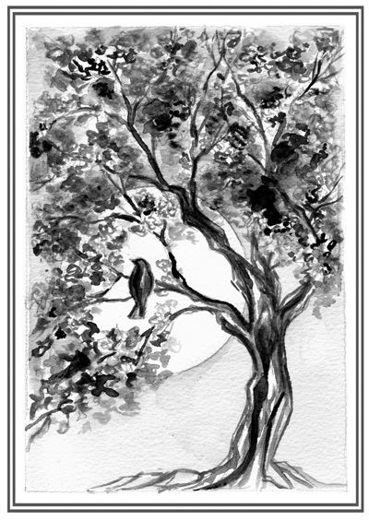
In the case of human beings it is an even more risky business. “Weeding-out” has no history of success which doesn’t seem to curb people’s passion for it. Seventy years after Hitler’s final solution, the horrendous weeding out of six million Jews in concentration camps, the Bosnian Serbs are attempting the brutal policy of “ethnic cleansing.” Race, religion, colour, sex, politics are still considered ready-reckoners for identifying society’s weeds. Increasing power over nature provides new and sinister instruments for weeding out. The unborn child, the seed of life is threatened with abortion. At the other end of life, euthanasia is proposed as the final solution for the new Jews, the old, the maimed, the incurables and the burdensome. Right through life, the weeding-out continues remorselessly. The handicapped axe institutionalised, the delinquent are penalised, the deviant are ostracised and the poor are patronised.
Weeding out is not confined to faceless bureaucracy. We’re all tempted to try our hand at it. We are sharp at spotting the undesirables, the troublemakers, the misfits. One shudders to think of the people who might have been weeded out if God had not chosen to intervene. Probably most of the saints in the calendar. Peter, after his triple denial in the crucifixion crisis should have been weeded out for failing the leadership test. Strange isn’t it, that Christ never weeded out Judas? The church did not always show her master’s tolerance. Galileo could testify to that. The spirit of the Inquisition lives on. Excommunications and anathemas may be out of fashion but old habits die hard.
The parable of the weeds is starkly simple and yet widely ignored. To the question “Do you want us to go and weed it out?” the answer of Jesus is a categorical “No.” And the reason is self-evident. Only God has eyes sufficiently discerning and fingers sufficiently gentle for this job. Weeding out is God’s prerogative. Life would be so much better for everybody, if only we would leave it to him.
